ISLAMIC UNIVERSITY OF TECHNOLOGY
Organization of Islamic Cooperation
Board Bazar, Gazipur

Laboratory Report 01
CSE 4512

Title: Configure router using static routing to connect multiple networks in Cisco Packet Tracer
Objectives:
- Understand how to operate Cisco Packet Tracer
- Learn to create and connect multiple networks using static routing
- Understand wiring of different network components like router, switch, PC etc.
- Configure router and switch interfaces
- Verify connectivity of the network
Diagram of the experiment:
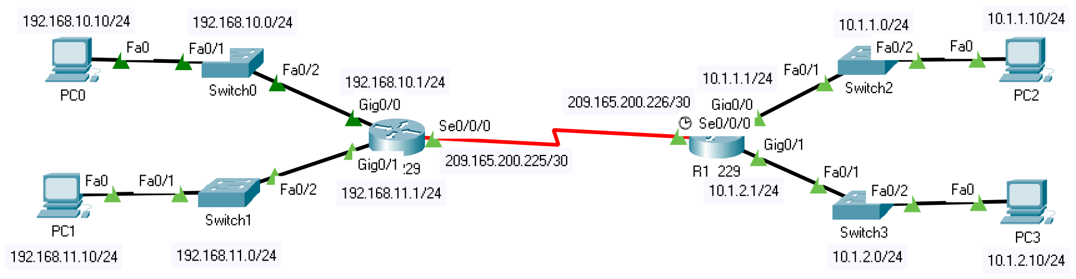

Working Procedure:
- All the required devices were set up as shown in the diagram above.
- The initial settings for Router0 were configured using its CLI as shown below:
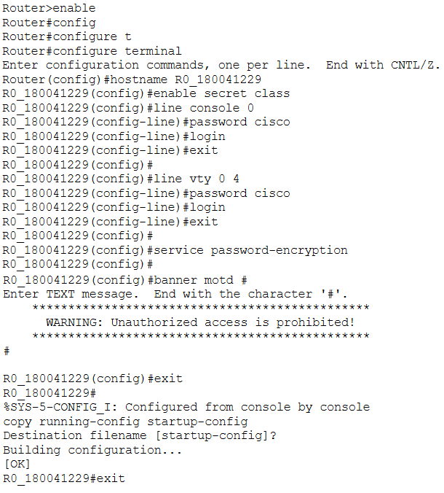

- The initial settings for Router1 were configured using its CLI as shown below:
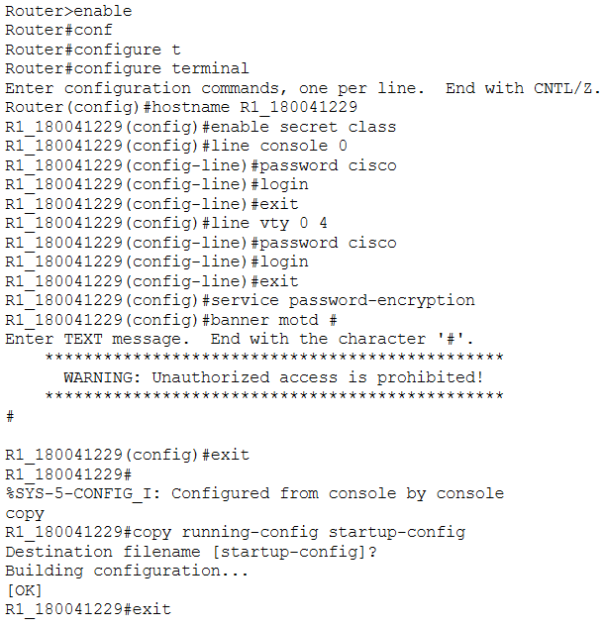

- The interfaces for Router0 were configured using its CLI as shown below:
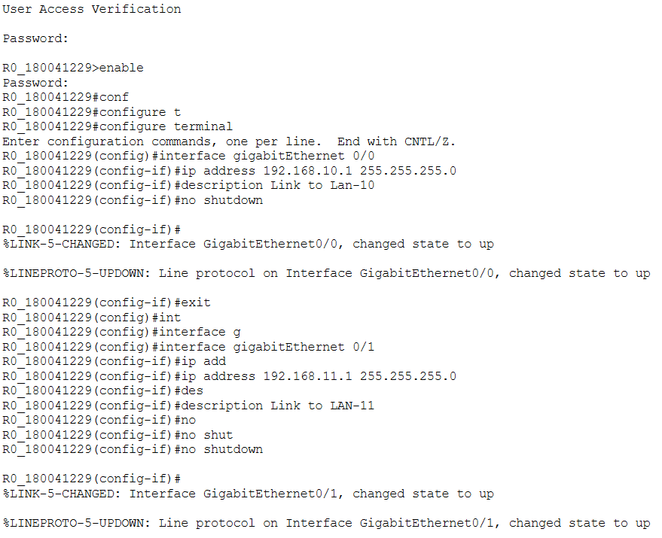
- The interfaces for Router1 were configured using its CLI as shown below:
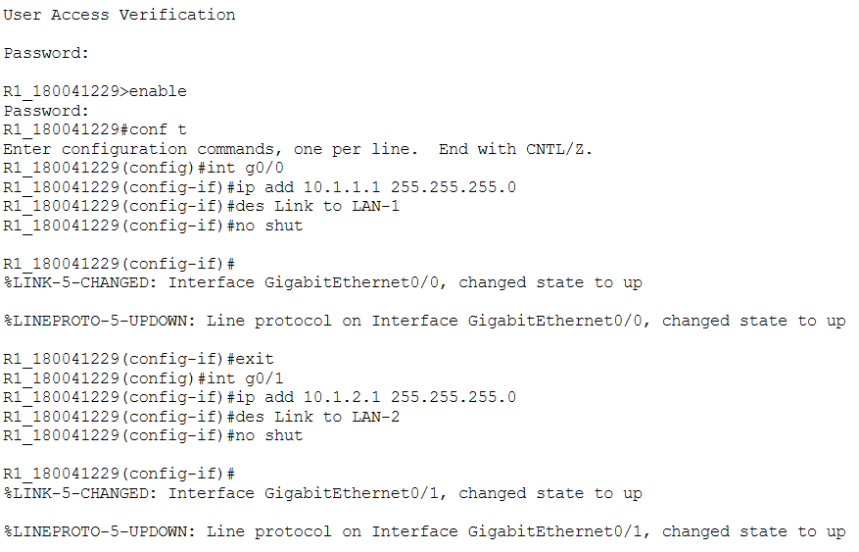
- The IP address and default gateway for each PC was configured in turn.
PC0:
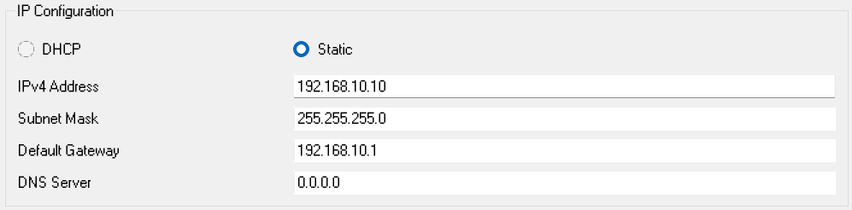
PC1:
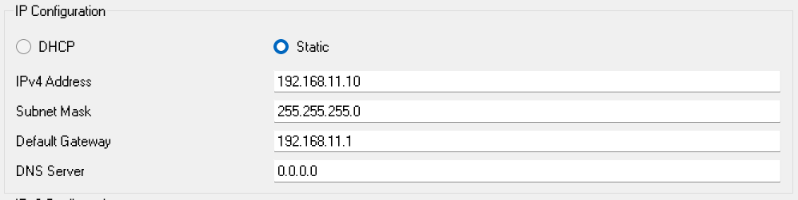

PC2:
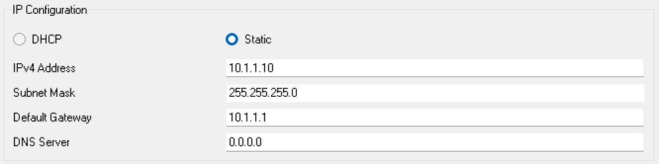
PC3:
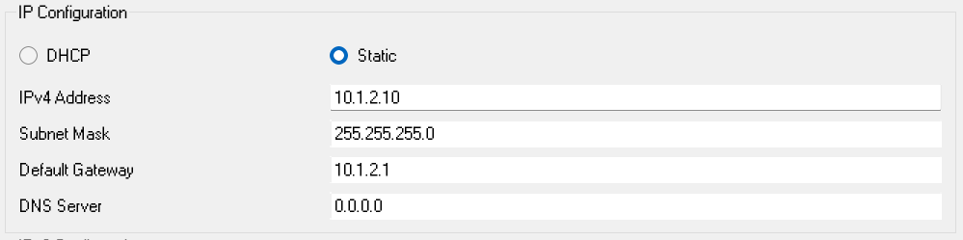
- Serial ports were added to each of the routers in turn:
Before:
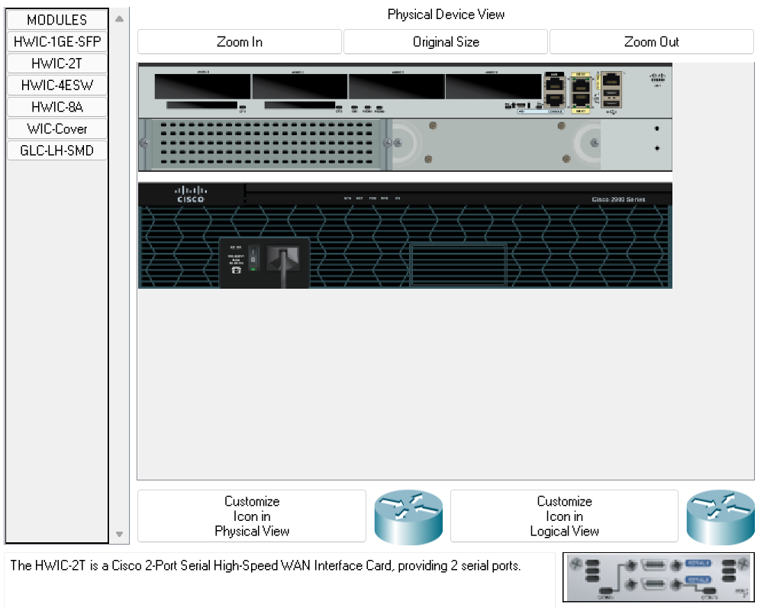

After:
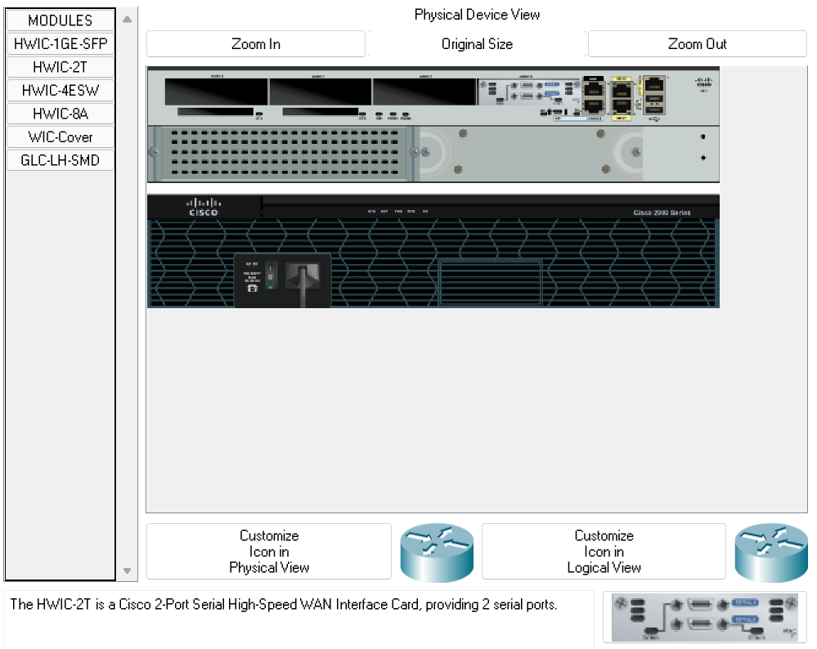
- The serial port interface for Router0 was configured using its CLI as shown below:
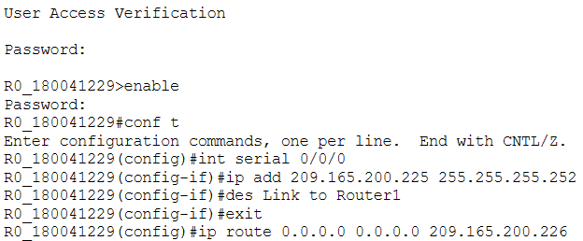
- The serial port interface for Router1 was configured using its CLI as shown below:
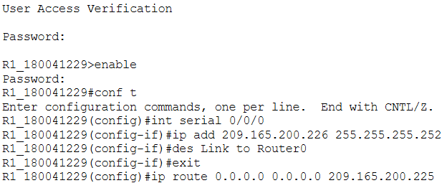
- The interfaces of each router were verified using their respective CLIs as shown below.
Router0:
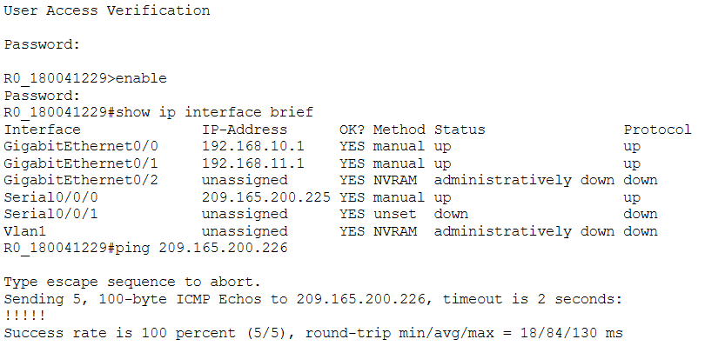
Router1:
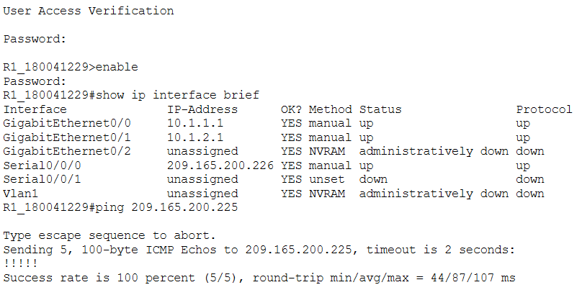
- It was verified that each PC could reach its respective gateway router.
PC0:
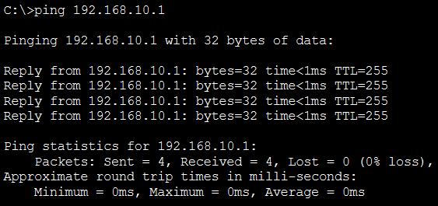
PC1:
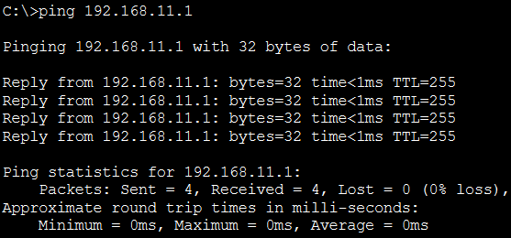
PC2:
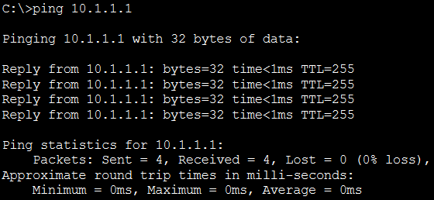
PC3:
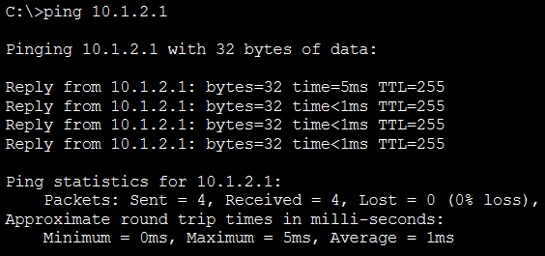
Questions:
Question: Write the command for adding a motd banner with the string "Restricted Access. Only for authorized individuals."
Answer:
banner motd #
Restricted Access. Only for authorized individuals.
#
Question: What is the recommended way of enabling password in a cisco device? Why it's better than other methods?
Answer: The recommended way is to use the following command from the CLI in global configuration mode:
enable secret somePassword
This method is better than the normal method to set passwords. This is because the normal method saves the password as plain text, which is risky. This method encrypts the password and saves the MD5 hash for the password instead, which if much safer.
Question: What are the differences between DCE and DTE cables?
Answer:
When a connection is being made using a serial interface, one of the devices must transmit clock signals, which controls the data rate. This device is called the Data Communication Equipment (DCE). The other device is called the Data Terminal Equipment (DTE).
In Cisco Packet Tracer, the difference between a DCE cable and a DTE cable is just which device we are connecting the cable to first. If we use a DCE cable, we are saying that the first device we click on is the DCE while the second device is the DTE. If we use a DTE cable, we are saying the opposite.
Reference
Question: Write the command to check the status of all interfaces in a router.
Answer:
show ip interface brief

Question: How do you make all the configuration changes in a cisco device persistent? What would happen if you don’t do this?
Answer:
The configuration changes to a device are saved to the running configuration by default. These changes are saved to the RAM of the device, which means if we switch the device off, the changes will be lost.
In order to make the configuration changes persistent, we must save the changes to the start-up configuration. Then, the changes would be saved to the NVRAM of the device and would not be lost even if the device were switched off.
We can do this using the following command in the privileged mode of the CLI of the device:
copy running-config startup-config
Challenges:
The only major challenge faced was with the serial port connections for the two routers. The tutorial found at this link served as a guide as to how to add serial ports to the routers and the interface configuration for the serial interfaces were done based on the interface configurations for the gigabit ethernet interfaces as well as this tutorial. However, there are gaps in understanding here which needs to be discussed.

